Thank you for registering for the Praying Through ministries “Through the Wilderness Virtual 5k”. Praying Through ministries is fully funded by generous donors and faithful supporters like you! 100% of the proceeds of your race tees will be used for outreach to our NICU, PICU, and Child Loss families.

We pray this Virtual 5k Walk/Run will bless your family and friends as you gather together to either celebrate the NICU/PICU Graduates in your lives or to honor your children who are living in Heaven. Don’t forget to take pictures and post them to social media using the hashtag #prayingthroughthewilderness5k

In this editable document you will find 10 unique race bibs. You can delete the bibs you do not want and copy the ones you choose to print and attach to your race tee with safety pins. In place of identifiable numbers, we have decided to personalize bibs with the name of the child(ren) you are running/walking to celebrate/honor. Simply click “insert” and “wordart.” The image below is with size 120 font.

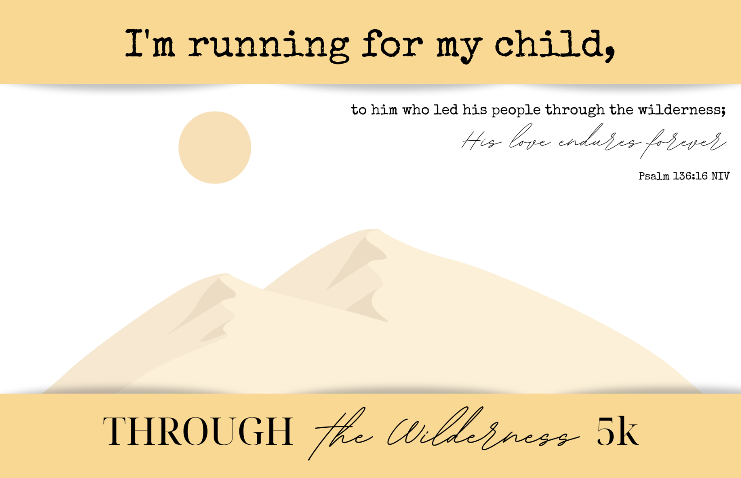
LANEY
